DETECTION OF DISEASE IN PLANTS USING RWSA AND FUZZY LOGIC
Nageswara Rao Moparthi¹, G. Balakrishna²,J Siva Prashanth³
¹Department of Computer Science and Engineering, Koneru Lakshmaiah Education Foundation, India
^{2,3}Department of Computer Science and Engineering, Anurag Group Institution, Hyderabad.
Corresponding Author: Me2balu@gmail.com,Rao1974@gmail.com

Abstract—In recent technologies related to agriculture growing rapidly, at this stage, an automatic disease finding system for crops is necessary. In this investigation, a fast and accurate crop disease finding system has been implemented with the help of fuzzy technique and RWSA optimization. The inputs of system are a crop digital images which are collected from digital camera placed at the agriculture field. This image has been processed in two stages at first stage pre-processing is performed, at second stage regression and classification has been attained. The previous methods by using GA, PSO, DE, Conventional and modern methods gives less accuracy and PSNR. Such that proposed a method FLRWS, this application improves the accuracy, MCC, SSIM, PSNR. This implementation compares with an existed method and concludes that the design method is better. The classification gives statistical analysis and true positive rate. The t p is near to one; therefore, sensitivity automatically improves. This investigation gives the crop disease, and related fertilizer, so designed implantation has been used for advanced agriculture methods.
Keywords— Fuzzy c, RWSA, Disease.

- INTRODUCTION

Here the usage of fuzzy C algorithm and also the Run-Way Scheduling Algorithm(RWSA) provides an insight into the agricultural problems in the lives of the farmers. The main aim of Fuzzy C algorithm is to partition the huge agricultural data into finite number of segments. After that it used to analyse the partitioned data and derive an output from the sample of the agricultural data which is the huge IOT data. It has to be noted that the output of Fuzzy C algorithm is fed as input to the Run-Way Scheduling algorithm. In this way, these algorithms work. It works for the benefit of plants in the fields and farmer to check the healthiness of the plants easily. So by checking he can come to know with these approach, identify the disease affected and also respective fertilizers also used for the cureness of the affected disease.
A. IMAGE ACQUISITION
The plant leaf images were captured through the camera and also the images were taken from Indiana pines website 2mb image folder and 100 kb .mat dataset size. These images are in RGB (Red, Green and Blue) form, color conversion structure for the RGB leaf image is created, and then, a device-independent color space transformation for the color transformation structure is applied.
a. Before filtering b. After filtering
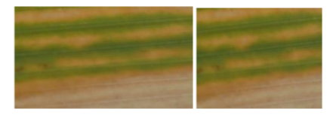
Fig 1: Sample diagram for image smoothing

2. LITERATURE SURVEY

One of the fruits that is extensively grown in Iran is pomegranate plants. They are typical plants that are grown in Gulf countries. Hence they have to be safeguarded. Gulf countries have a tropical atmosphere. They have to be protected from the diseases that are used to infect the crop. The infection starts from a leaf and reaches the entire crop. After this the crop is damaged. Hence care has to be taken to remove the disease.
We are using the image processing techniques to identify the crop diseases. The image of the pomegranate leaf is taken from a close distance. This image of the infected leaf is stored in the database. After that this image is compared with the image of the healthy leaf and then disease is identified. After that the fertilizer is sprayed on the leaf in order to eliminate the disease from the pomegranate plant. [7][17]
Generally in the country like Iraq, the practice of agriculture is very less. Because of its typical climate conditions, there are a few plants that are grown in this country. Generally tomato plants are grown in the agricultural fields. On a case study of the plant, we found that there are viruses that affect the plant. These are to be removed.
By using the K-Means clustering algorithm the disease that has affected the tomato plant is identified. A clear image of the leaf is taken and compared with healthy leaf to determine the disease. Once the disease is determined , the specified fertilizer with the given name is used to kill the virus and remove the disease from the crop.[12][18]
In countries like New Zealand, plants like tomato is grown in large numbers. Also there are diseases that are used to affect the crop in the plants. We use different algorithms to solve the problem. However there are parasites that are affecting the plant. These parasites are identified with the help of the fuzzy algorithm. This algorithm contains specific prototypes of the model of the potato plant. The leaf of the potato crop is taken. Nearly 20-30 leaves are studied by taking an image of the crop. They have to be precise in order to determine the algorithm. These images are processed and stored in the database. By using segmentation the disease is identified and hence it is removed from the potato plant by using the specified fertilizer. [4][16,28]
There are few vegetable crops that are grown in Sri Lanka to feed the hunger of millions of people in the country. There are some viruses that are affecting the vegetable crops in the fields. They have to be removed in order to prevent the damage of crops in the fields. For this we are using the different algorithms for solving this problem. These problems are occurring in large numbers and hence there is a need to solve the problem. By using the K-Means segmentation, we are used to take the image of the leaf of the vegetable crops in the agricultural fields. After that the image processing techniques are used to process the image. Hence the disease of the plant is determined and hence the fertilizer that has to be sprayed on the vegetable plant is determined.[15,26]
In the country like West Indies, there is a bacterial leaf spot that affects the paddy crop in the agricultural areas. There are a few lands that are suitable for agriculture . In these lands, the agriculture is practiced. This is used to satisfy the hunger of the people. Also it has a tropical atmosphere that supports the plant. Incidentally, there is a bacteria called bacterial leaf spot that affects the crops in the rice fields[19,29].
This bacterial leaf spot is dangerous for the rice crop. It damages the rice crop in the agricultural fields. By using the Fuzzy algorithm , we are used to identify the disease and also remove the disease by using the appropriate fertilizer that affects the rice crop. The image of the rice crop is taken and this image is further processed to detect the disease that has affected the plant and stop it before it reaches the entire plant in order to prevent the damage of the rice crop. Once the disease is detected, The appropriate fertilizer is used to reove the disease.[10]
In this case, we are studying the paddy leaf disease detection in the Indian state of Odisha. Generally, there may be a bunch of paddy crops in a selected area in the agricultural fields. There has been a study on the different types of diseases that are used to affect the paddy crops in the fields. These cause a serious problem to the paddy crops. Thereby affecting the paddy crop and reducing them to a large extent. They cause a serious issue to the crop. These diseases are very much dangerous to the human kind. Also we have found a solution to this problem. [21,25]
By using K-Means segmentation, we are used to determine the type of disease that has affected the crop. This procedure is used to determine which type of disease has affected the crop and hence finding the solution to this type of problem. After scanning the disease, we are going to specify which type of fertilizer is to be used to remove the disease and increase the crop production. This is the solution to this problem. [11][20,27]
There have been paddy crops in the state and there are diseases that are affecting the plants in the crop areas. These are used to determine the cause of disease and hence implement the process to find a reliable solution to this problem. This problem has occurred to the crop plants especially paddy crop. We have to solve this problem in a systematic way. For this we use K-Means segmentation method to identify the disease and remove the disease. We have been known that there are certain crops in the fields that are used to specify the particular plant growth. These diseases are used to hamper the growth of plants. We should find out the parasites affecting the plants. The picture of the plant is taken and the taken image is processed to determine the disease. After identifying the disease, we suggest the certain fertilizer to spray on the crop to determine the disease.[13,26]
We have to know that Rajasthan is a desert area and there are high chances of heat in this state. So there are a few places that are adjusted and suitable for agriculture in the state. Hence we know that growing plants in these areas is a tough task. We have to determine which disease has affected the plant. For that we use image-processing mechanism to identify the type of diseases that are affecting the plants. After acknowledging this, we have to determine the fertilizer that has to be sprayed on these rice crops to remove the disease from the rice crops. In this way, paddy diseases are removed.[8][18]
We can say that Uttarakhand is a cool place. Since it is located to the north of India, we are finding it difficult to grow paddy crops in the Indian state of Uttarakhand. We know that prevention is better than cure. However, we can say that there are diseases that are infecting the crops in the farm lands. So the farmers are taking the images of the crop from a near distance and the image is fed as an input to the image processing algorithm . The image is compared with the database image of the healthy leaf and hence the disease is determined. Generally bacteria and virus are used to infect the plants in the fields. The specific fertilizer is determined to be sprayed on the crop to remove the disease. In this way, the disease is removed from the crop before it infects the entire crop and the problem is solved.[9][22]
We can tell that Himachal Pradesh is a very chilly place, Only there are a few lands which are suitable for farming. However there is a chance of contamination of the food grains and hence care has to taken to prevent this. What we infer is that the diseases are infecting the entire crop. This results in the damage of the crop. We have to determine the disease that has affected the crop in the agricultural fields. We use image processing techniques to determine the disease that has affected the plant. We shall use these specific algorithms to detect the disease of the plants. The image of the rice crop or the paddy crop is taken by the peasant. He has to take it from a close distance in order to specifically diagnose the problem. After the diagnosis , the disease is detected that has affected the crop. Generally , the fungi affects the leaves of the rice crops in the agricultural fields. By using the specified fertilizer that has to be sprayed on the crop suggested by the algorithm , the diseases are eliminated from the crop. Hence this is the way to solve the problem.[1][23-24]

- PROPOSED METHOD
The fuzzy logic is used to divide the load into segments. This is for the division of the given segment that is used to reduce the load of the given data-set. The IOT data is supplied as the input data. Here the agricultural data is the input data. Here the data-sets are huge enough that are presented as input. The fuzzy C algorithm is used to partition the given huge data-sets. The Otsu method is used generally for image processing. This is because of its simple calculation. In this process, we are using the jpg images for comparing the original images with the image of the healthy leaf. The code is apt enough to supply the required output. They have to distinguish between good seeds and bad seeds. For this, the fuzzy logic supplies the segmented data as an input to the run-way scheduling algorithm. The disease that has attacked the plant is used to damage the plant. This disease is generally caused by bacteria, fungi and viruses. Basically there are three types of diseases that infects the crops in the fields. They are rice blast, brown spot and narrow brown spot diseases. These diseases are harmful to the rice crop. First of all, the disease has to be detected. For this, we use Fuzzy C algorithm to partition the agricultural data which is a huge data-set. Fuzzy C is used to resolve the given IoT data which is very large since the agricultural data is large it consists of large data sets. Along with Fuzzy C algorithm, the K means clustering is used to partition the given data set. After the segmentation is done, the data sets are put into the specified clucters this is very much useful in leaf disease detection. Here our aim is to identify the diseases that are infecting the leaves and damaging the crops. The results in the damaging of the crops that are grown in the agriculture fields these diseases that affect the plants in the farm lands starts with the leaf. We can observe the disease by identifying the spot on the leaves which are affected with the bacteria. This bacteria is harmful to the plants that are grown in the farm lands these prove to be dangerous as it affects the rice crops, pomegranate plants, sugarcane plants etc. and consequently damages the crop. It has to be avoided it is often said prevention is better than curing of the infected plants. To remove the diseases from the plant there by eliminating the disease from the plants this results in increasing of the rice production and saves the crop from the danger.

3. 1 FUZZY C
The fuzzy C algorithm is fed as an input to the Run-Way Scheduling algorithm(RWSA). In this way, the fuzzy logic is used to divide the heavy load into light load. In this way, this is used to solve the problem using the fuzzy C method. The disease that is damaging the crop results in reduction of crop production. As a result, the crop is damaged. The image of the leaf of the crop is taken. After the Otsu method, the image of the crop is taken. This is done to extract the features from the image of the leaf. Here there is a conversion from RGB color space to L*a*b* color space which consists of luminosity layer. This is called the chromaticity layer. Then apply the color form. Classify the color from a* and b* color space. Since the image has three colors, we need to create three clusters. And then measure the distance using Euclidean distance. It consists of ‘n’ rows and ‘n’ columns. Store the results of the clustering in a blank cell array. After extracting the features from segmented image, convert it to grey scale if the image is RGB color. Evaluate the disease affected area using the black and white image. In the black and white image, we can clearly figure out where the disease is affected and the healthy leaf is there. Create the grey-level co-occurrence matrices. This is known as grey chromatics. GLCM. Derive the statistics from GLCM like contrast, co-relation, energy, homogeneity, mean, standard deviation, entropy, RMS, skewness, variance, smoothness and Kurtosis. Load all the features and put the test features into variable test. Fuzzy logic is an approach for computing based on degrees of truth values rather than the usual. It is similar seems closer to the way our brains work which we aggregate the data and form a multiple number of partial truths which we again aggregate into higher truths, when certain thresholds were exceeded, causes certain results such as motor reaction.
  - RWSA
1. Creating an initial population
2. Isolation non-dominated members of the people and storing them in a repository
3. Tabulation the discovered target space
4. Start of each particle movement after selecting the leader from the members in a repository
5. Updating each particle’s best memory
6. Adding non-dominated members of the current population in the repository member
7. Removing dominated members of the repository
8. Removing additional members and re-tabulating if the repository members are more than the determined capacity
9. If termination conditions are not met go back to number 3, otherwise it should be terminated

Fig: 2 RWSA Algorithm

3. 3. FLOW OF ARCHITECTURE

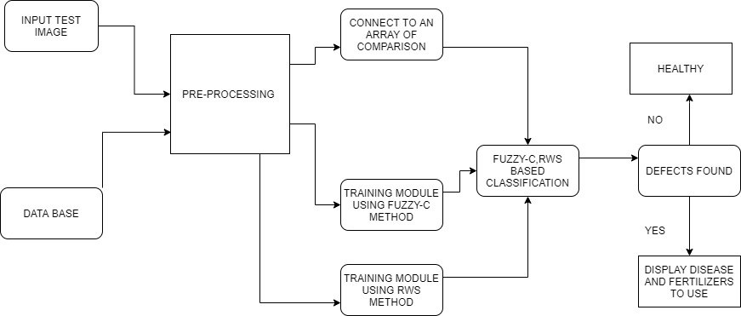

Fig 3: Flow of architecture

Here in the activity diagram firstly the input image has been taken as a leaf if it is failure then it will shows that there is no input image otherwise if it success it extracts the features, classifies based on fuzzyc and Runway scheduling and detects the leaf if there is no disease it will be healthy leaf and if there is a disease it is infected and need to provide best fertilizers to cure that disease.
3. 4. MODULES
3. 4. 1. Image pre-processing module
User will upload dataset directory. In this module, preproceesing takes place. All images will be resize to 300*300 px. Step by step it process the image. In image clipping cropping of the leaf image is used to get the interested image region. Image smoothing is done using the smoothing filter which reduces the rough creature particles from the leaf image after filtering. Before filtering the image size will be some what bigger after filtering the image will be cropped and adjusted.
3. 4. 2. Classification Module
The process of sorting or arranging pixels in an image into classes or clusters is the main theme of classification. Classification of binarized data is used to assign corresponding levels with respect to groups with homogeneous characteristics, with the aim of discriminating multiple objects from each other within the image. Classification is also a type of pattern recognition. Here the pattern of images of healthy and diseased leaf is recognized and the conclusion is made.
Healthy image
If the image is green in colour we can easily conclude that the plant is not affected with any disease.
Diseased Image
If the leaf image is in brown or other than green colour we can identify the disease by using fuzzyc and runway scheduling algorithms.

Healthy image Diseased Image
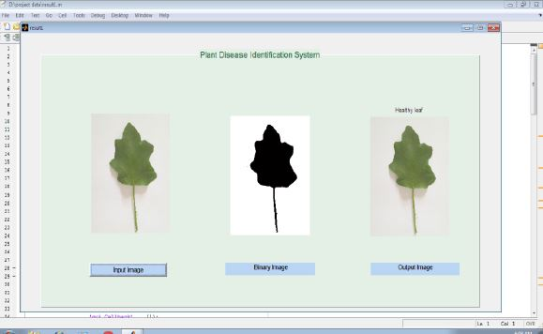 | 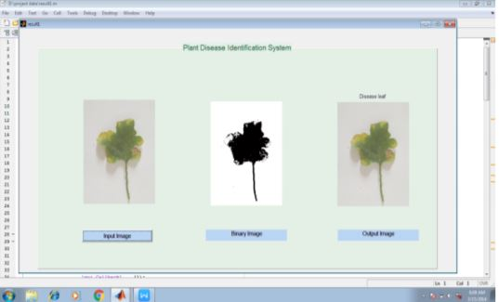

Fig 4: Sample images for helath and diseased
3. 4. 3. Disease Detection Module
In testing phase, user upload query image. Then image pre-processing, feature extraction, classification will perform and finally leaf image will classify as diseased or non-diseased. Generally we can observe the symptoms of disease on leafs, stems, flowers etc. so here we use leaf images for identification of disease affected plants.
3. 4. 4. Parameters
Input: plant leaf images.
Algorithms: Fuzzy c ,Run way scheduling, Otsu Thresholed Segmentation.
Output: Leaf Disease, Fertilizers to be used to cure that disease.
4. RESULTS AND DISCUSSIONS
Steps for execution
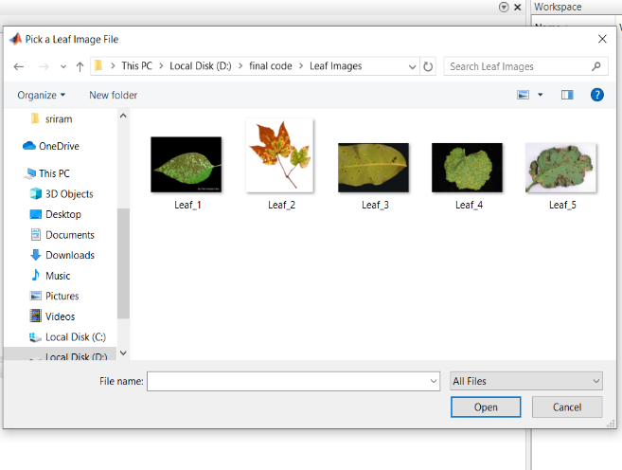 | 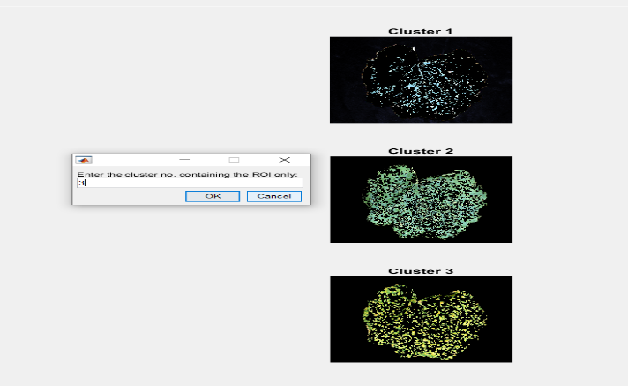
Step 1. Pick a leaf image from the folder in the matlab software | Step 2. Enter the cluster number
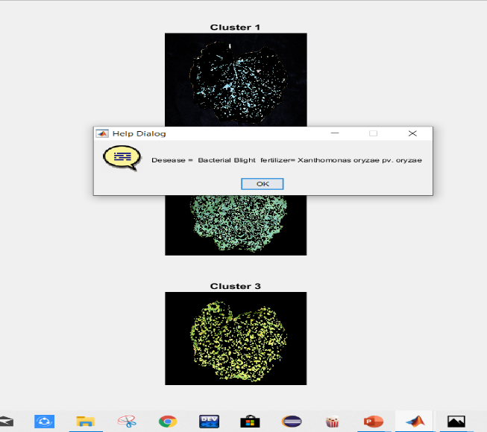 | 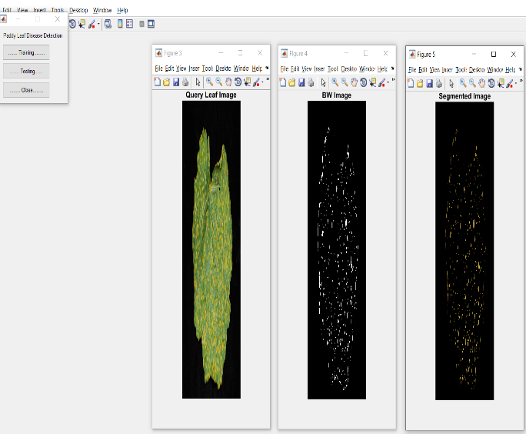
Step 3. Displays the Affected Disease and provides fertilizer to cure that affected disease | Step 4. Training and Testing Phase
Step 1 It indicates in the matlab software there will be a option to run the program if we click on it it displays to select a leaf image from the folder. We need to choose a leaf image by clicking on all files with a file name.
Step 2 After choosing the leaf image from the folder it displays the three clusters and we need to choose one cluster to identify the disease infected on the leaf image and also provides the fertilizer to cure that infected disease. So manually enter a number on the provided text box.
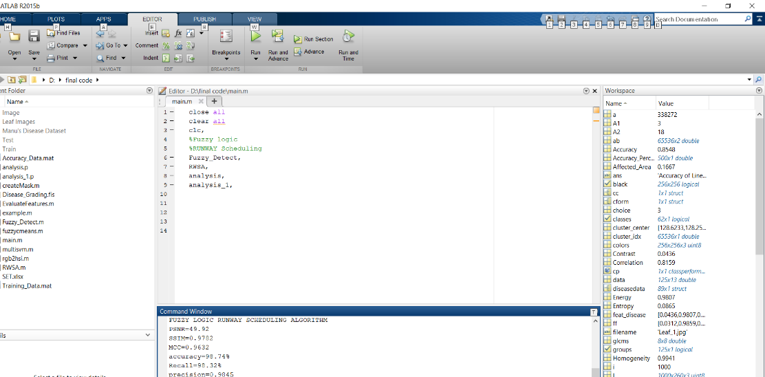
Step 5. Accuracy

Step 3 Here it displays the affected disease on the leaf image and provides the best fertilizers to cure that affected disease.
Step 4 In the training phase the originally leaf image is compared with data set image to perform segmentation phase and conversion of black and white image and in the testing phase it shows the results of images for the segmented phase and black and white image.
Step 5 so, finally the overall accuracy for the perfect identification of the disease affected on the plant and fertilizers used is 98.74%.

5. COMPARITIVE ANALYSIS

Proposal | Culture | Diseases | No.of images considered | Accuracy | Features | Image Acquisition | Methodology
Jitesh P.Shah[5] | Paddy crop leaf | Leaf blast,brown-spot | 40 | 87.3% | Color, shape and textures | images are captured from the farm using a digital camera to get them directly in digital form with numerical value. | K-Means clustering and Otsu’s method
Manoj Mukherjee [6] | Paddy crop leaf | Bacterial blight, brown spot disease, Rice tungro | 50 | 92.7% | Color and shape | Images are captured from digital camera produced area in West Bengal | RGB method with clustering
Gittaly Dhingra[3] | Rice crop leaf | Brown spot, rice blast and sheeth rot | 50 | 93.15% | Color and shape, position | Images are captured from digital camera with pixel  size 768*1048 | Image processing
Shikhar  Kr. Sarma[14] | Rice crop leaf | Brown spot and bacterial blight | 40 | 85.3% | Color and shape | Images are captured from digital camera produced area in Assam | Fuzzy
Dr. Neha Mangla [2] | Rice Crop | Rice Blast,  Brown Spot of Rice, and Sheath Blight of Rice |  | 93% | Shape and color | Images are captured from digital camera | Otsu’s method / thresholding
Propsed Algoritham | Balakrishna | Bacterial blight, brown spot disease, Rice tungro | 50 | 98.74 | Color and shape | Images are captured from digital camera | RWSAand FUZZY

6. CONCLUSION
Here the proposed methodology uses run way scheduling and fuzzy c algorithms for clustering, segmentation and identify the affected type of disease. Suppose if the disease is Alternaria Alternata, then the respective fertilizers like nitrogen, potassium is used to cure the disease. If the disease is Anthracnose, the calcium nitrous oxide is used as a fertilizer. If the disease is bacterial blight, the xanthomonas oryzae is used as a fertilizer and if the disease is cercospora leaf spot, the fertilizer used is blend balanced with potassium. Overall identification accuracy is 98.74%.

Refernces
- Ajay Kumar Gautam, Heena Gupta and Yamini Soni, “Screening of Fungi and Mycotoxins Associated with Stored Rice Grains in Himachal Pradesh”, International Journal of Theoretical & Applied Sciences, 4(2): 128-133(2012).
- Dr. Neha Mangla , Priyanka B Raj , Soumya G Hegde , Pooja R, “Paddy Leaf Disease Detection Using Image Processing and Machine Learning”, international Journal of Innovative Research in Electrical, Electronics, Instrumentation and Control Engineering Vol. 7, Issue 2, February 2019.
- Gittaly Dhingra, Vinay kumar and Hem Dutt Joshi, “Study of digital image processing techniques for leaf disease detection and classification”, Springer Science+Business Media, LLC, part of Springer Nature 2017.
- G.N. Webby & R.C. Close, “Aetiology of the leaf roll disease of potatoes in New Zealand”, NewZealandJournal ofCropandHorticultural Science. 1991. Vol. 19: 167-175.
- Jitesh P.Shah, Harshadkumar B.Prajapati, “A Survey on Detection and Classification of Rice Plant Diseases”, 978-1-5090-1936-6/16/$31.00 ©2016,IEEE.
- Manoj Mukherjee,Titan Pal and Debabrata Samanta, “Damaged Paddy leaf detection using Image processing”, 2017 International Journal of Global Research in Computer Science (JGRCS).
- Mohammad Salehi, seyyed Alireza Esmailzadeh Hossaine, Rasoul Rasoulpour, Elham Salehi, Assunta Bertaccini, “Identification of phytoplasma associated with pomegranate little leaf disease in Iran”, 0261-2194/2016 Elsevier Ltd.
- Pratima Yadav and subroto dutta, “Detection of pesticide residues in feed samples using paper strip assay : A study of Ajmer city,Rajasthan”, Jpp 2019 8(3):4420-4422.
- Pratyush Pant, Prayash, Aditya Bhandari, Pratyush Joshi, Ashok Kumar, “Study and comparison analysis of different image processing techniques for plant diseases”, ISO 9001:2008 Certified Journal Impact Factor value: 7.211 2018, IRJET.
- P. PRIOR and P. ROTI, “Bacterial Leaf Spot of Anthurium (Anthurium spp.) Caused by a Pseudomonas sp. in the French West Indies”, J.Phytopathology 124,215-224 (1989) © 1989 Paul Parey Scientific Publishers, Berlin and Hamburg ISSN 0931-1785.
- Prabira Kumar Sethy, Baishalee Negi, Nilamani Bhoi, “Detection of Healthy and Defected Diseased Leaf of Rice Crop using K-Means Clustering Technique”, International Journal of Computer Applications (0975 – 8887) Volume 157 – No 1, January 2017.
- Rakib A. Al-ani, Mustafa A. Adhab, Samir A. H. Hamad and Saber N. H. Diwan, “Tomato yellow leaf curl virus (TYLCV), identification, virus vector relationship, strains characterization and a suggestion for its control with plant extracts in Iraq”, African Journal of Agricultural Research Vol. 6(22), pp. 5149-5155, 12 October, 2011.
- Shazia Iram and Iftikhar, “Prevalence and disease incidence of foliar blight of wheat cropping system of Punjab”, Pak. J. Bot., 37(4): 973-980, 2005.
- Shikhar Kr. Sarma, Kh.Robindro Singh, Abhijeet Singh, “An Expert System for diagnosis of diseases in Rice Plant”, International Journal of Artificial Intelligence, Volume(1): Issue(1)
- W.M.E.K. Bandaranayake, W.R.K.T. Wickramarchchi, H.A.M. Wickramasinghe, R.G.A.S. Rajapakshe and D.M.K.K Dissanayake, “Molecular Detection and characterization of begomoviruses associated with Cucurbitaceae vegetables in Srilanka”, J.Natn.Sci.Foundation Srilanka 2014 42(3): 265-271.
- G Balakrishna* and Nageswara Rao Moparthi, “An Optimal IoT Device Placement Strategy for Agro-IoT using Edge Computing”, Recent Advances in Computer Science and Communications (2020) 13: 1. https://doi.org/10.2174/2666255813666191216122801
- Pavan Kumar, T., Lala, S. K., Sravani, B., & Sandeep, A. (2018). Internet of things survey on crop field smart irrigation automation using IOT. International Journal of Engineering and Technology(UAE), 7(2.8 Special Issue 8), 503-506.
- Umadevi, K., Lalitha, S. V. N. L., & Chetwani, S. H. (2019). Dynamic modeling for improvement in power quality issues of DFIG wind farms interconnected with grid. International Journal of Innovative Technology and Exploring Engineering, 8(5), 663-668.
- avindran, G., Madhavi, M. R., & Abusahmin, B. S. (2018). Optimization of zinc(II) adsorption using agricultural waste. International Journal of Engineering and Technology(UAE), 7(3.34 Special Issue 34), 300-304.
- G.Balakrishna and Moparthi Nageshwara Rao “ Study report on Indian agriculture with IoT “International Journal of Electrical and Computer Engineering
- Somasundar, A. V. S. S., Yedukondalu, G., Subhani, S. K., Azgar, S. K., Srinivas, Y., & Ganneshwar, G. (2018). Mini paddy crop cutting and straw separation rover. Journal of Advanced Research in Dynamical and Control Systems, 10(4), 354-361.
- Mekala, M.S., Viswanathan, P. (t,n): Sensor Stipulation with THAM Index for Smart Agriculture Decision-Making IoT System. Wireless Pers Commun 111, 1909–1940 (2020). https://doi.org/10.1007/s11277-019-06964-0
- G.Balakrishna and Moparthi Nageshwara Rao,” ESBL: Design and Implement A Cloud Integrated Framework for IoT Load Balancing” International Journal Of Computers Communications & Control ISSN 1841-9836, e-ISSN 1841-9844, 14(4), 459-474, August 2019.
- Balram, G., & Kiran Kumar, K. (2018). Smart farming: Disease detection in crops. International Journal of Engineering and Technology(UAE), 7(2), 33-36. doi:10.14419/ijet.v7i2.7.10252
- Narayana, B. V. V. S., Ravi, K. S., & Ramesh, N. V. K. (2018). A review on advanced crop field monitoring system in agriculture field through top notch sensors. Journal of Advanced Research in Dynamical and Control Systems, 10(6 Special Issue), 1572-1578Pavan Kumar, T., Lala, S. K., Sravani, B.
- Sandeep, A. (2018). Internet of things survey on crop field smart irrigation automation using IOT. International Journal of Engineering and Technology(UAE), 7(2.8 Special Issue 8), 503-506.
- Narayana, B. V. V. S., & Ravi, K. S. (2017). IP camera based agricultural reforms. Journal of Advanced Research in Dynamical and Control Systems, 9(3), 19-25.
- Navulur, S., Sastry, A. S. C. S., & Giri Prasad, M. N. (2017). Agricultural management through wireless sensors and internet of things. International Journal of Electrical and Computer Engineering, 7(6), 3492-3499.
- Asadi, S. S., Kumar, M., Kumar, N., & Rajyalakshmi, K. (2017). Estimation of runoff for agricultural utilization using geoinformatics: A model study from telangana state. International Journal of Civil Engineering and Technology, 8(10), 472-483.

